**Project Design Phase**

**Solution Architecture**

|  |  |
| --- | --- |
| Date | 27 June 2025 |
| Team ID | LTVIP2025TMID32546 |
| Project Name | Smart Sorting: Transfer Learning For Identifying Rotten Fruits and Vegetables |
| Maximum Marks | 4 Marks |

**Solution Flow Diagram:**

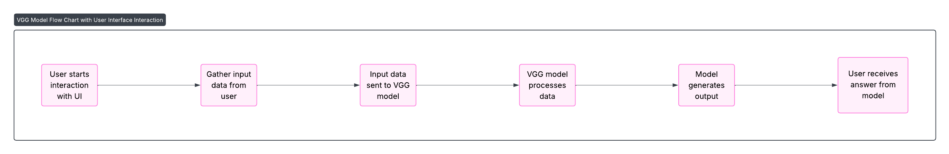

*Figure 1: Flow diagram*

**Solution Architecture:**

User → Image Upload → Flask API → VGG16 → Prediction → Display Output